Adapted from: Edith Cowan University. (2019). ECU Quick Guide to APA Referencing. Retrieved from https://ecu.au.libguides.com/ ld.php?content _id=30117643/

APA Referencing

**What is Referencing?**

Referencingis a standardised method of acknowledging sources of information and ideas of other people that you have used in your own work and a way of uniquely identifying those sources. When you are writing an assignment, essay, or report you need to read from a wide range of sources, such as books, journal articles and reports. All sources, both published and unpublished must be referenced.  
  
Referencing is an essential part of academic writing at university to:

* acknowledge the work of other writers;
* demonstrate the depth of your research;
* support your arguments or opinions put forward in your work, and;
* avoid [**plagiarism**](https://ecu.au.libguides.com/referencing/why-reference)

Making a reference to these sources is called citing. You can cite in the text and at the end of your paper. References in-text are known as [**in-text citations**](https://ecu.au.libguides.com/referencing/in-text-citations).

References at the end of your paper are known as end text referencing or the [**reference list.**](https://ecu.au.libguides.com/referencing/reference-list) This is where you reference the **full publication details**of each item according to the APA style.

There is a difference between a reference list and a bibliography. A reference list is a list of all the sources cited in your work, whereas a bibliography is a list of all the works that you used to research your topic, including the works you did not cite in your assignment.

**Avoiding plagiarism**

It is very important that if you are using work which is not your own that you reference it in your text appropriately. Placing a bibliography or reference list at the end of your work without identifying when you have used another person’s work can be counted as plagiarism. Copying and pasting or handwriting webpages and submitting the work as your own is also plagiarism. As stated in the Narrogin Senior High School (NSHS) Whole School Assessment Policy,

“All work submitted for assessment must be the original work of the student, unless the alternative source is acknowledged. Students shown to have cheated in assessed work will receive a **zero mark** for the task.Collusion is when a student submits work that is not his or her own for assessment. Plagiarism is when a student uses someone else’s work or ideas and passing them off as one's own without acknowledging the source. If work that is not the original product of that student is submitted for assessment, it will be deemed **not to have been completed**. Students may be awarded a result for work which can be authenticated,” (NSHS, 2019, 1.10).

**What is APA Referencing?**

APA is the referencing style set by the American Psychological Association. It consists of two parts:

1. In-text Citation: a short reference (author, date) contained within the text of your assignment; and
2. End-text Reference: the full citation details of each reference used in the text of your assignment.

Every in-text citation should have a corresponding end-text reference, and every work referenced in the end-text reference list should have at least one in-text citation.

**In-text Citations**

In-text citations must be included each time you use the words or ideas of another writer. When quoting directly from a source, you must use quotation marks, e.g. According to Blackwood, “it was a matter of give a little, take a little,” (Grenville, 2005, p. 78). If you are paraphrasing someone else’s work (putting it into your own words), Direct quotations must also include a page number, e.g. (Wheelen & Hunger, 2008, p. 23). Use the paragraph number or section heading for electronic sources with no page number, e.g. (Basu & Jones, 2007, para. 4). If you are not quoting directly, follow your lecturer’s preference about page numbers.

The format of in-text citations can differ depending on how you choose to structure your sentence but must always contain the author and date.

**End-text References**

The end-text reference list provides full citation details of a work based on the following four elements:

1. **who** produced the work (i.e. author, which might be an organisation or a person)

2. **when** was the work produced (i.e. date of publication)

3. **what** is the work we are referring to (i.e. title of the work)

4. **where** did this work come from (i.e. publisher or online source)

All end-text reference list citations have the following format as their underlying structure: Author, A. A. (year). Title. Source.

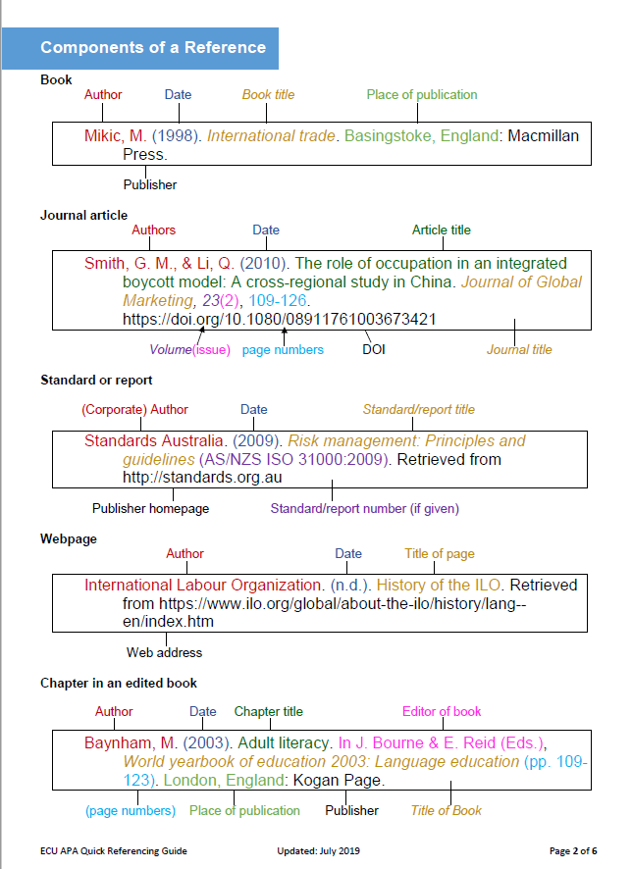

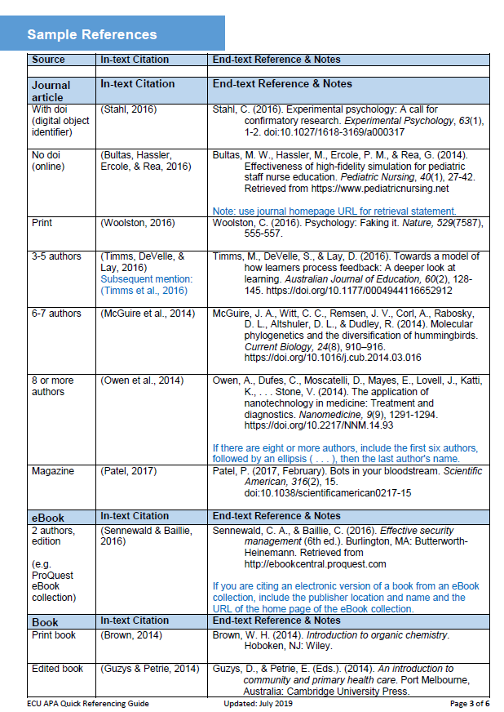

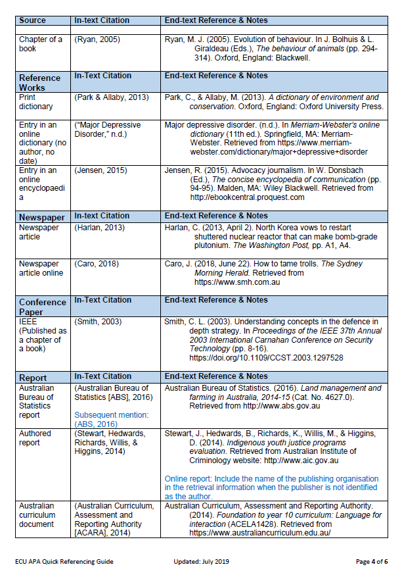

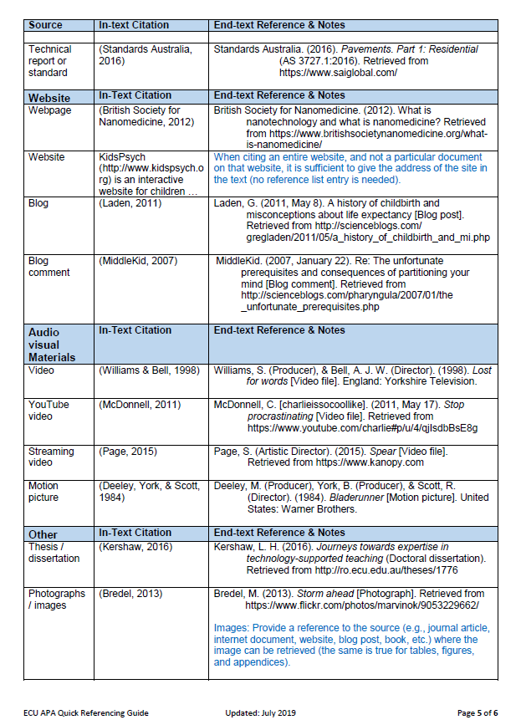

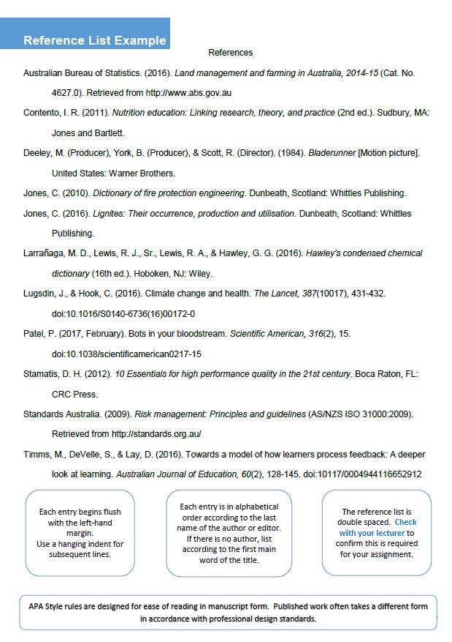

**Activity:**

Using the information provided, and the tables on the previous pages, use the following sources in an in-text reference by introducing and quoting from the text and create a reference list.

1)

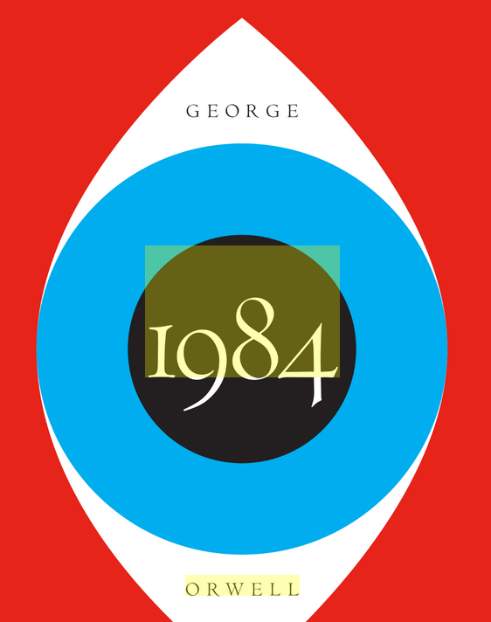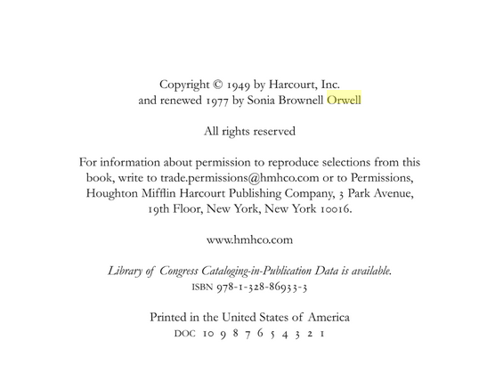

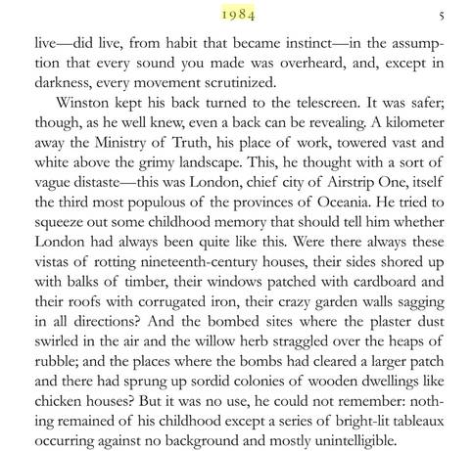

2)

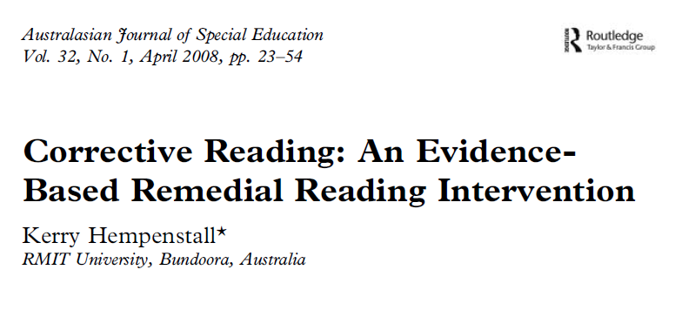

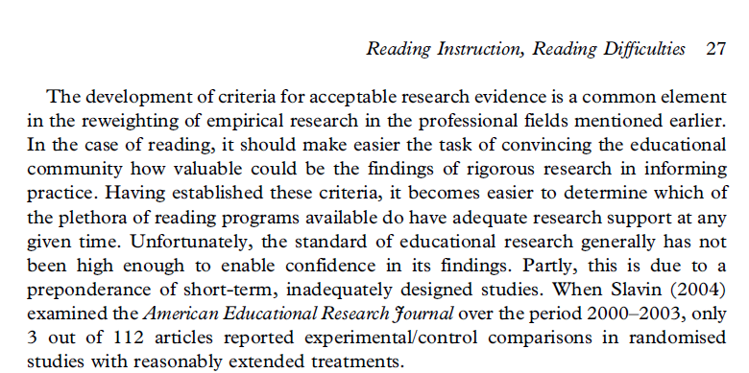

3)

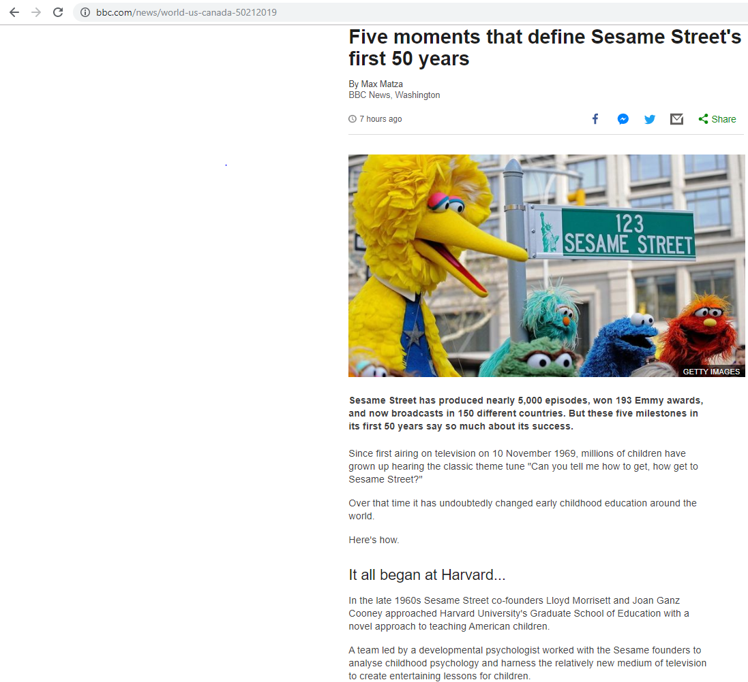

4)

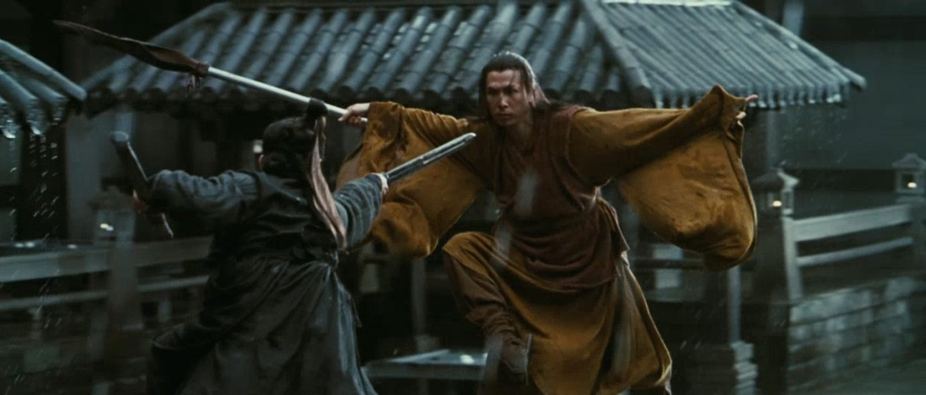Still from the film, *Hero*. Year: 2002. Written by Feng Li, Bin Wang, Zhang Yimou. Produced by Zhang Yimou. Directed by Zhang Yimou. Production Company: Sil-Metropole. Distributed by Miramax films (US).

5)

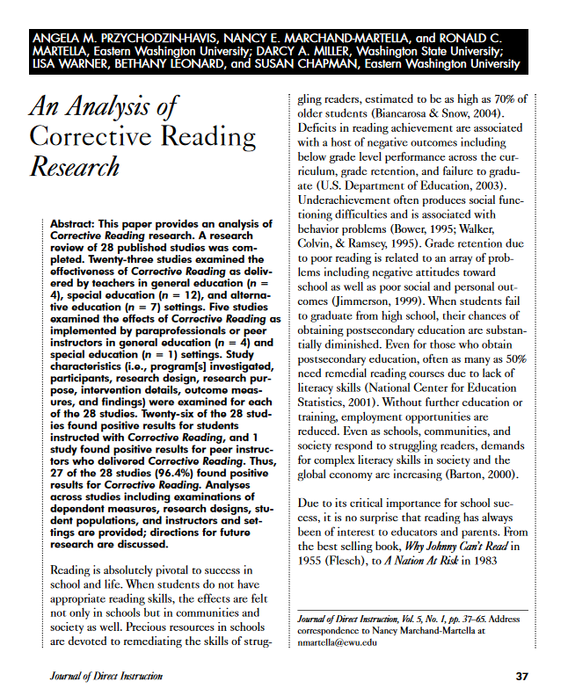

6)

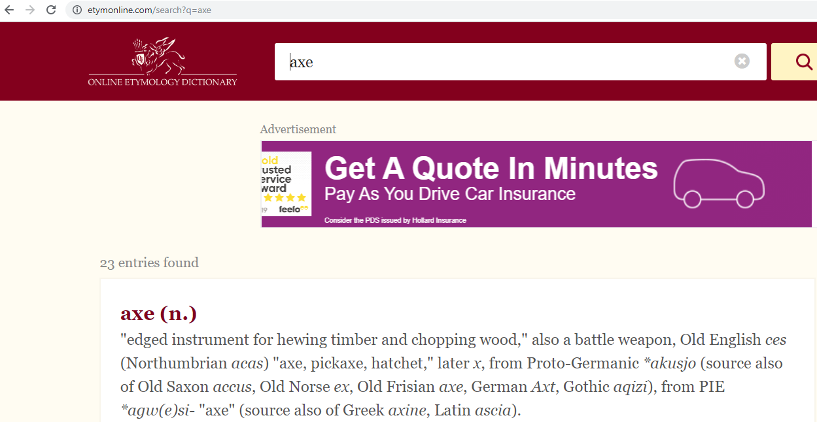

7)

